
“Ký Ức Vàng”
“ Câu chuyện cuộc đời của Bố / Mẹ”
Subject : EXE101
Lecturer : Hoang Kien Trung
Class : Group 3 - SE1939-NJ

Students | ID
Phạm Gia Bảo | HE186509
Nguyễn Đức Cảnh | HE161293
Nguyễn Lê Hải Đăng | HE190809
Nguyễn Thị Hoàn | HS186445
Lương Ngọc Minh | HE186139

FPT University, Ha Noi - 2026

Table of Contents
1. Marketing Mix Plan 4
I. PRODUCT 4
1. Product Analysis Using the Three Levels of Product Model 4
1.1. Core Values 4
1.2. Actual Product 4
1.3. Augmented Product 5
2. How the Product Works 6
2.1. Context Diagram 6
2.2. User Requirements 7
2.2.1 Actors 7
2.2.2 Use Cases 7
2.3. Screens Flow Overview 9
2.3.1 Screens Flow Context Diagram 9
2.3.2 Screens Description 10
2.3.3 Non-UI Functions 11
2.4 Operational Process 11
II. PRICE 12
1. Why Is the Pricing Strategy Crucial for Ký Ức Vàng? 12
2. Selected Pricing Strategy 13
2.1. Value-Based Pricing 13
2.2. Perceived Value Pricing 13
Pricing Configuration for Brand Positioning and Customer Choice Optimization 14
2.3. Cost-Based Pricing 14
3. Pricing Structure 14
4. Competitive Pricing Strategy and Market Positioning 15
III. Place 17
1. The Role of the Distribution Strategy for Ký Ức Vàng 17
2. Selected Distribution Strategy and Rationale 17
3. Distribution Channel Structure 18
Prospect Acquisition Channels – Where Customers First Discover the Project 18
Core Information and Sales Channel – The Primary Source of Orders and Revenue Generation 19
IV. PROMOTION 20
1. Promotional Tools and Implementation 20
1.1 Advertising 20
1.2. Sales Promotion 20
1.3 Direct Marketing 21
1.4 Personal Selling 21
1.5 Public Relations - PR 22
2.Communication Framework 22
V. PROCESS 24
1. The role of Process within the Ký Ức Vàng Business Model 24
2. Product Development Process 25
3. Customer Acquisition Process 26
VI. People 27
1. The role of human capital within the organization 27
2. Roles of individual members within the Ký Ức Vàng founding team 28
VII. Physical Evidence 29
1. Pre-access Touchpoints 29
2. While-using Touchpoints 30
3. Post-access Touchpoints 30
2. Implementation Roadmap 31

Marketing Mix Plan

I. PRODUCT
Ký Ức Vàng is not merely a printing service or a conventional storage application. It is a comprehensive, human-centered technology solution designed to help families preserve their parents’ life legacy through an innovative combination of a proactive Artificial Intelligence system and a premium handcrafted publishing process. The solution operates on a hybrid experience model that effectively bridges generational gaps, addresses the busy lifestyles of adult children, and prevents the loss of valuable family memories and materials over time.
At the heart of the solution is the transformation of elderly parents’ stories and fragmented memories into a unique family memoir and a multigenerational digital archive. Adult children act as coordinators and companions throughout the process, while parents become the storytellers, weaving the pages of their life story using their own familiar voices through an intuitive and highly familiar conversational interface.

1. Product Analysis Using the Three Levels of Product Model
To conduct a comprehensive analysis of Ký Ức Vàng, the team applied the Three Levels of Product Model to clarify the value that the system delivers at different levels.

1.1. Core Values
Ký Ức Vàng is positioned as a family bonding and digital legacy preservation solution, serving as an emotional bridge between generations through intelligent technology. The core value delivered by the system goes far beyond that of a conventional interview or book-printing service. Instead, it focuses on addressing psychological barriers-such as children’s feelings of guilt for not spending enough time with their parents and the loneliness often experienced by the elderly-while also “freezing time” to permanently preserve parents’ voices, photographs, and life stories for future generations.

1.2. Actual Product
Ký Ức Vàng is a family legacy preservation service powered by localized AI technology and delivered through a familiar messaging platform (Zalo). The interface and user experience are built around a Hybrid UX approach (“Children Purchase – Parents Share”), which simplifies the process for elderly users by enabling voice-based interaction and direct conversations with AI or human interviewers. Parents can respond by sending voice recordings or text messages without the need to write by hand or type lengthy content themselves.
From a functional perspective, the system periodically sends guided prompts, receives responses in the form of voice recordings or messages, uses AI-powered Voice-to-Text technology to convert speech into written narratives, and restores old family photographs through image enhancement technology. The final deliverable is a Legacy Preservation Bundle consisting of a professionally printed hardcover memoir book-serving as a treasured family heirloom-and a cloud-based digital archive that securely stores original voice recordings and family photographs for future generations.

1.3. Augmented Product
Ký Ức Vàng further strengthens its competitive advantage through advanced features designed to address concerns related to information security and service flexibility. The system provides a Hidden Encryption feature that converts sensitive memories or delicate family stories into password-protected QR codes, allowing families to preserve important personal histories while maintaining privacy and family harmony.
In addition, the project adopts a Modular Pricing model and a Dynamic Pricing mechanism based on actual operational usage. This approach not only offers customers greater flexibility in selecting services but also creates positive incentives for adult children to remain actively involved in the process, regularly communicating with and encouraging their parents to participate. As a result, the memoir creation journey becomes more than a preservation project-it serves as a meaningful opportunity for families to strengthen intergenerational communication and connection.

2. How the Product Works

2.1. Context Diagram
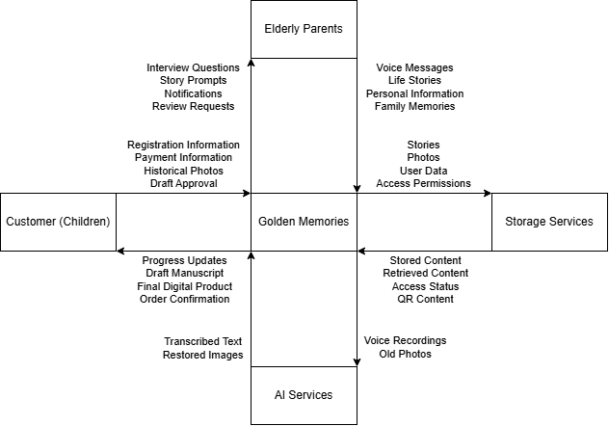
Ký Ức Vàng operates through the integration of the Zalo platform, which serves as the primary interaction interface for end users, and the Ký Ức Vàng Core System, which functions as the project’s central management platform.
Primary Actor 1 – Purchaser (Adult Children): Responsible for registering service packages, monitoring project progress, paying operational fees, providing historical family photographs, and reviewing or approving memoir drafts.
Primary Actor 2 – User (Parents): Receives scheduled storytelling prompts through Zalo and can simply press a voice-message button to share personal stories and memories directly through voice recordings.
External Systems: The platform integrates with a Voice-to-Text AI service to convert parents’ voice recordings into draft text, an Image Restoration AI service to enhance and restore old family photographs, a Secure Cloud Storage system that stores data within a permission-controlled architecture, and a Printing Service responsible for publishing and producing physical memoir books.

2.2. User Requirements

2.2.1 Actors
 | Actor | Description
1 | Buyer - Children | Service Registration, Payment, Progress Monitoring, Family Photo Upload, QR Code Security Configuration, and Draft Approval.
2 | User - Parents/Grandparents | Receive periodic prompts from a Zalo Bot or a dedicated specialist and interact with the system by recording voice messages to share life stories and personal memories.
3 | External System - AI Service | A specialized AI system designed to process audio noise, convert Vietnamese voice recordings into text (optimized for regional accents and dialects), and automatically correct spelling errors in draft transcripts.
4 | External System - Storage & Security Service | A secure private cloud architecture that encrypts family data and provides controlled access through password-protected QR codes, particularly for sensitive memories, personal secrets, or delicate family matters.
5 | Super Admin | Has full administrative control over the entire system, including managing all customers, editorial teams, service packages and pricing, viewing financial reports, configuring user roles and permissions, handling complaints, and overriding any system action when necessary.
6 | Editor | The application sends Zalo messages, processes audio recordings using AI-powered transcription technology, edits memoir content, manages assigned customer projects, customizes interview question sets, restores old photographs, submits draft versions for purchaser approval, and delivers the final product upon completion.

2.2.2 Use Cases
Functions for Adult Children: Register an account → Select product modules and service packages → Monitor parents’ interaction and response progress → Upload family materials and historical photographs → Configure hidden QR Code encryption settings for sensitive content → Review and approve the printed book layout and draft → Pay dynamic operational fees.
Functions for Parents: Receive storytelling prompts via Zalo (organized into four life stages: ages 0–18, 18–40, 40–60, and over 60) → Record voice responses to share memories and life experiences → Listen to recordings and re-record responses if desired.
Functions for Editor: See customer in charge → Send your questions via Zalo → Download audio to your device → Upload to Google Drive → Audio processing using AI → Content editing → Restore old photographs → Submit draft.
Functions for AI: Process audio noise → Convert Vietnamese voice recordings into text → Auto-correct spelling errors in draft transcripts → Restore and enhance old photographs.
Functions for Cloud: Store stories, photos, and user data securely → Encrypt sensitive family data → Set up password barriers → Generate password-protected QR codes.

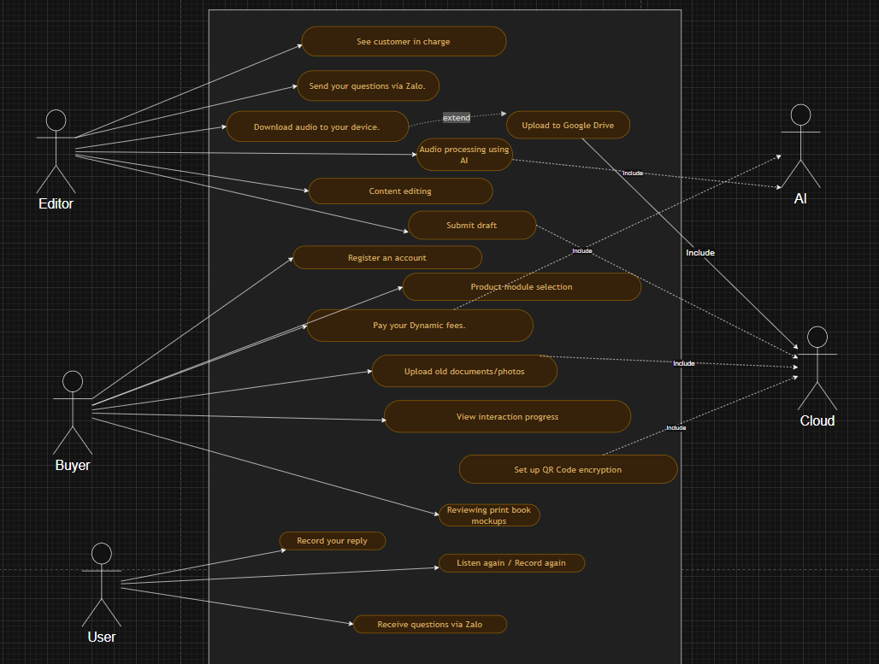

Automated System Functions: Automatically send scheduled storytelling prompts → Convert audio recordings into text through AI-powered transcription → Restore and enhance old photographs using AI technology → Automatically format and layout memoir drafts for publication → Calculate service fees dynamically based on the actual duration of project operation.

2.3. Screens Flow Overview

2.3.1 Screens Flow Context Diagram
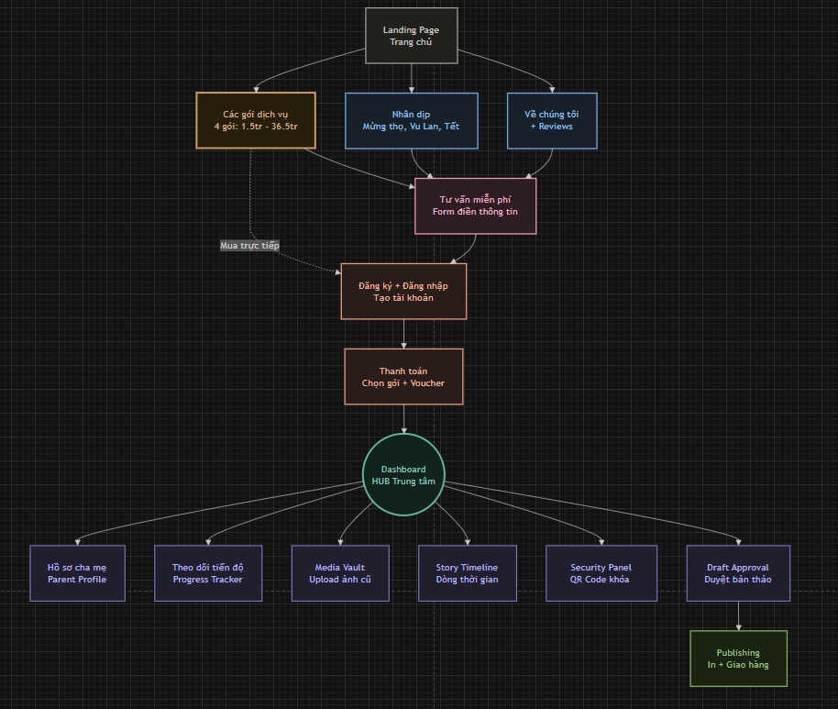
Activation & Connection Screen: Allows adult children to register their parents’ information and connect their parents’ Zalo phone numbers to the Ký Ức Vàng system.
Progress Dashboard: Displays a hierarchical timeline organized into four life stages, the number of completed questions, pending questions, and a real-time progress tracking indicator.
Media Vault: A centralized repository where adult children can upload and organize historical family photographs according to memoir chapters, enabling AI-powered image restoration and enhancement.
Editor & Security Panel: Allows users to preview text transcribed from parents’ voice recordings. It also includes a “Hidden Encryption” feature that converts sensitive content into password-protected QR codes for enhanced privacy and controlled access.
Payment & Pricing Screen: Displays operational fees calculated on a weekly or daily basis according to actual usage and allows users to manage optional upgrade packages, such as hardcover memoir printing and cloud-based digital heritage archive services.

2.3.2 Screens Description

 | Features | Screens | Description
1 | Activation & Connection | Registration & Connection Screen | The purchaser registers an account, enters parent information, and connects the parent's Zalo account to the system.
2 | Parent Profile Management | Parent Profile Screen | Displays personal information, connection status, and memoir project information.
3 | Progress Tracking | Dashboard Screen | Displays memoir completion progress across 4 life stages, alongside the number of completed and pending questions.
4 | Media Management | Media Vault Screen | Upload, view, and organize old photos according to respective memoir chapters.
5 | Image Restoration | Image Restoration Screen | View and compare the original photos side-by-side with the AI-restored versions.
6 | Story Management | Story Timeline Screen | Displays collected stories systematically categorized by life stages.
7 | Voice Transcription | Transcript Review Screen | View the text content converted from voice recordings by the AI engine.
8 | Memoir Editing | Editor Screen | Edit, add to, and finalize the memoir content.
9 | Content Security | Security Panel Screen | Configure private QR Codes, set up password protection, and manage access permissions for sensitive content.
10 | Draft Approval | Draft Approval Screen | The purchaser previews and formally approves the final memoir manuscript layout.
11 | Payment | Payment Screen | Manage service packages, track dynamic operational costs, and process payments.
12 | Publishing | Publishing Screen | Order physical book printing services or generate a digital museum hosted on the Cloud.

2.3.3 Non-UI Functions

 | Feature | System Function | Description
1 | Voice Processing | AI Voice-to-Text & Auto-Correction | Automatically filters audio noise, analyzes regional dialects, converts raw audio into text, and subsequently auto-corrects basic grammatical and spelling errors to generate a rough manuscript.
2 | Archival Restoration | AI Image Restoration | Automatically routes low-quality, old family photographs to the AI module to enhance facial clarity, balance lighting, and upgrade the resolution.
3 | Manuscript Packaging | Auto-Layout Engine | Automatically arranges and formats the layout of the rough manuscript once the audio transcription and photo restoration are completed.
4 | Encryption & Security | Data Encryption & QR Code Generation | Encrypts sensitive data segments upon request, establishes password protection barriers, and automatically generates a secure QR Code ready for print integration.
5 | Fee Calculation | Dynamic Pricing Engine | Continuously monitors the parents' actual response frequency to automatically calculate and adjust operational fees based on the actual number of active days.
6 | Automated Reminders | Push Notification Engine | Automatically sends reminder notifications or milestone reports to the adult child's app if the parents' recording process is interrupted due to a busy schedule.
7 | Publishing & Delivery | Auto-Export & Cloud Sync | Automatically publishes digitized files (Ebook, original audio files) to a secure cloud storage platform (Secure Cloud), while packaging and transferring the final manuscript layouts to the printing partner's system.

2.4 Operational Process
The operational workflow of Ký Ức Vàng outlines how the system functions, coordinates data, and processes information throughout the entire interaction between the family and the platform. Once the adult child registers an account and connects the service, the system initiates the cycle of heritage collection, processing, and data security through automated workflows integrated with artificial intelligence.
Per the pre-established schedule (e.g., during fixed rest periods of the elderly), the system automatically activates and sends conversational, prompt-based questions to the parents' Zalo account. When the parents interact by sending voice messages sharing their life stories, this raw audio data is immediately transmitted to the central system to be classified into its corresponding memoir chapter.
For intelligent features and advanced data processing:
- Voice Processing: The parents' raw audio data is transferred to a localized AI service to filter noise, analyze regional dialects, and convert speech into text (Voice-to-Text), subsequently auto-correcting basic grammatical errors to generate a rough manuscript.
- Archival Restoration: When the adult child uploads low-quality, old family photographs, the system automatically routes the data to an AI restoration module to enhance facial clarity, balance lighting, and upscale the resolution.
- Encryption and Security: When the family activates the security feature for sensitive content, the system encrypts that specific data segment, sets up password protection, and automatically generates a secure QR Code ready to be integrated into the printed layout.
Parallel to that process, a Dynamic Pricing Engine continuously monitors the parents' actual response frequency. If the recording process is interrupted due to the family's busy schedule, the system automatically adjusts the operational fee structure while sending automated reminders (Push Notifications) or milestone reports to the child's app, prompting them to call and encourage their parents.
Once all life stages are completed and approved, the system automatically publishes the digitized files (Ebook and original audio files) to a Secure Cloud storage platform, while simultaneously packaging and transferring the final manuscript layouts to the printing partner's system to produce and deliver the physical hardcover book directly to the family.

II. PRICE

1. Why Is the Pricing Strategy Crucial for Ký Ức Vàng?
A pricing strategy plays a vital role in the success and survival of a social behavior-transforming startup project like Ký Ức Vàng. Unlike conventional tech applications, this project faces two major hurdles: Vietnamese consumers do not yet have the habit of paying for personal heritage digitization services, and the product operates on a complex experiential model (Children pay – Parents experience). As a new brand entering the market, setting a price point that is too high initially would instantly extinguish any consumer intention to test the service.
The target customers making the purchasing decisions for Ký Ức Vàng are adult children within the U25 to U40 age bracket. They are employed individuals who have begun accumulating financial savings, often living far from home or facing busy schedules, and consistently carrying a sense of anxiety and guilt for not spending enough time with or deeply understanding their parents. Therefore, the pricing must be carefully calculated to fit the adult child's budget, while remaining high enough to reflect the sacred value and absolute security of a lifelong "family heritage," rather than resembling a low-cost ghostwriting or cheap printing service.
Although the current market lacks direct competitors offering "AI-driven digital memoirs," it presents indirect competition from manual biography services, family photography packages, or mainstream cloud storage platforms. Consequently, Ký Ức Vàng must establish an intelligent pricing structure that clearly decouples technological value (AI photo restoration, AI voice processing) from physical value (premium silk-bound printed books). The Premium version must demonstrate outstanding added value by freezing time and preserving the original voices of parents, thereby alleviating psychological pressure for their children. Implementing flexible pricing mechanics aligned with actual project progress will also minimize initial financial barriers, turning the service into a reasonable technological "catalyst" that naturally binds families together.

2. Selected Pricing Strategy

2.1. Value-Based Pricing
Ký Ức Vàng does not base its pricing on the number of printed pages or storage capacity (Megabytes), but rather on the emotional value and absolute uniqueness that customers receive:
- The Value of Permanence: The stories, voices, and photographs of parents and grandparents are digitized and permanently archived on a secure cloud platform, ensuring they never fade over time. This represents an invaluable spiritual heritage for future generations.
- The Value of Dissolving Generational Barriers: Instead of descendants struggling to find ways to prompt or record their elders' lives, Ký Ức Vàng’s professional team takes on that responsibility, executing it in the most delicate manner through in-depth interviews.
- The Value of Peace of Mind: The service helps the elderly feel that their lives are deeply cherished and listened to, reassuring them that the values they leave behind will live on forever in the hearts of their children and grandchildren.

2.2. Perceived Value Pricing

Pricing Configuration for Brand Positioning and Customer Choice Optimization
- Price Anchoring: Introduce a Premium tier with a very high price point (e.g., an AI-integrated memoir package). This anchor establishes the premium status of the brand while making the Economy or Standard packages appear much more "reasonable" and accessible in the eyes of customers.
- Bundling: Instead of charging individually for each separate service (interview fees, photo scanning fees, design fees), Ký Ức Vàng bundles everything into a comprehensive "Heritage Preservation Solution." Customers feel they are purchasing a holistic, thoughtful care service rather than buying individual items piece by piece.
- Culturally Resonance / Refined Numbers: Utilize price points that evoke a sense of comfort, prestige, and alignment with Eastern culture (e.g., ending in well-rounded numbers or auspicious figures; avoiding the cheap e-commerce ".99k" style endings, which would diminish the formal and solemn nature of the project).

2.3. Cost-Based Pricing
Selling Price = Base Cost + Desired Profit
The rationale behind selecting this strategy is to ensure absolute financial security for Ký Ức Vàng's physical components and on-site services (such as photo book printing, premium wooden gift boxes, interview travel expenses, and filming).
This method enables the business to easily calculate economic efficiency based on the actual expenses incurred for each specific order. Concurrently, it establishes a gross profit margin thick enough to comfortably deploy appreciation programs and discounts during special occasions (Mother's Day, Father's Day, International Day of Older Persons) without risking deficits in the startup's fixed capital.

3. Pricing Structure

Criteria | Package 1 - Express (15 days) | Package 2 - Bonding (1 month) | Package 3 - Leisurely (3 - 6 months) | Package 4 - Companion Heritage (1 year)
Memoir Type | Lifelong Memoir (Core summary) | Lifelong Memoir (Standard detailed) | Lifelong Memoir (In-depth/Lineage) | 1-year Diary combined with Memoir
Information Gathering Duration | Exactly 15 days | Within 30 days | From 90 to 180 days | Continuous 365 days
Gathering & Care Fee (100k/day) | 999k VND (Commitment milestone discount) | 3,000,000 VND | 9,000,000 VND - 18,000,000 VND | 36,500,000 VND
Deliverables & Specifications | - 50-70 questions sent via Zalo  - 100 color-printed pages  - Up to 5 old photos restored | - 100-150 questions  - 200 pages with silk hardcover  - Up to 5 old photos restored  - Audio recording files  - Integrated secure hidden QR codes | - Unlimited questions  - Unlimited memoir book pages  - Up to 20-25 old photos restored  - Archived voice recording files | - Unlimited questions  - Stage-by-stage chronological interviewing (Youth, Adolescence, Mid-life, Senior years)  - All original voice recording files  - Premium Cloud Digital Museum
Fixed Production Cost | Basic Production Fee | Standard Production Fee | Premium Production Fee | Special Production Fee
TOTAL SAMPLE PACKAGE PRICE | 1,500,000 VND | 3,000,000 VND | 9,000,000 VND | 36,500,000 VND

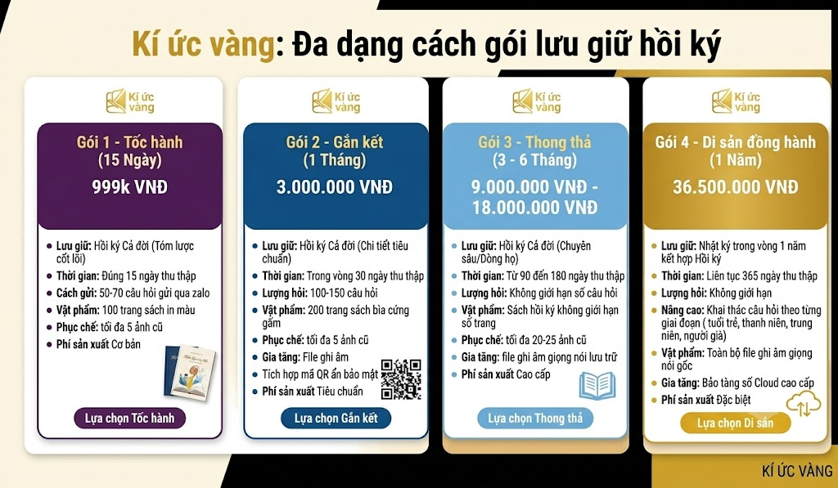

4. Competitive Pricing Strategy and Market Positioning

Comparison Criteria | Ký Ức Vàng | Viết Hồi Ký(viethoiky.com) | Be Heritage(hoiky.com.vn)
Core Pricing Philosophy | Pricing based on companionship duration (Daily Fee) combined with fixed production costs. Breaking down costs (~100k VND/day) to reduce psychological pressure on customers. | Pricing based on customer segmentation & status value (Family packages differ from those for entrepreneurs and politicians). | Pricing based on the volume of final deliverables (Word count in the manuscript, scale of accompanying media).
Entry-Level Pricing Tier | 999k VND (Package 1 - 15-day Express). | From 30,000,000 VND (Popular package for the elderly). | 15,000,000 - 30,000,000 VND (Basic package, slim book).
Mid-Range Pricing Tier | 3,000,000 - 18,000,000 VND (Package 2 - Bonding & Package 3 - Leisurely). | 75,000,000 - 85,000,000 VND (Family Diamond / Entrepreneur Classic packages). | 35,000,000 - 75,000,000 VND (Standard & Premium packages).
Premium Pricing Tier | 36,500,000 VND (Package 4 - 1-year Companion Heritage). | From 185,000,000 VND (Entrepreneur Pro, intensive package). | From 120,000,000 - 180,000,000 VND (Special package, including web portal/media production).
Information Gathering Duration | Flexible, fixed by package: 15 days, 30 days, 90-180 days, or 365 days. | Not fixed by days; calculated by the number of face-to-face interview sessions (typically 5 - 15 sessions). | Calculated by overall project timeline (typically spanning 2 - 6 months depending on book thickness).
Interaction / Interview Method | Remote and continuous interaction: Sending questions via Zalo (lower tiers) up to in-depth chronological interviewing across life stages (higher tiers). | Face-to-face interviews conducted at the subject's home or office for live audio and video recording. | In-person meetings with experts, combined with sourcing archives from family, agencies, and relevant organizations.
Question Quota | Limited by package: 50-70 questions, 100-150 questions, or Unlimited (premium package). | Not managed by question count; managed by interview duration (hours/session). | Unlimited questions, focusing on a pre-approved outline (table of contents framework).
Physical Deliverable Specifications (Printed Book) | Clearly defined quotas: 100 color-printed pages, 200 pages with silk hardcover, or Unlimited pages (Package 3 & Package 4). | Premium printed book, personalized design, flexible page count based on story length. | Printed according to publishing house standards, with length guaranteed by word count (e.g., basic package starts at 15,000 words).
Photo & Audio Services | Restoration of 5 - 25 old photos; premium package includes delivery of all original voice recording files. | New portrait photography sessions, scanning, and restoration of the subject's archival photos. | Archival photo editing, professional timeline graphic design, and family tree mapping.
Added-Value Technology | Integrated secure hidden QR codes and a premium Cloud Digital Museum system for storage. | Low focus on digital technology; primarily focuses on physical value (leather books, wooden gift boxes). | Supports building personal websites/web portals or digitizing ebooks (for corporate/business packages).

III. Place

1. The Role of the Distribution Strategy for Ký Ức Vàng
Ký Ức Vàng was developed to support families in preserving the life memoirs of parents, restoring archival photographs, processing voices, and packaging these elements into physical books combined with cloud-based digital archives. However, the true value of the project can only be fully realized when adult children can easily access the service, understand its workflow, and seamlessly integrate this storytelling journey into their parents' daily routines. Therefore, an effective distribution strategy does not merely ensure that the product appears before the target audience; it guarantees that the experience of accessing information, viewing product samples, and placing deposits happens in the most convenient and natural manner. Selecting the right distribution channels enhances visibility, captures interest, and drives purchasing behavior.
For Ký Ức Vàng, this is particularly crucial because the buyer segment making the financial decisions consists of busy adult children aged 25 to 40. This demographic is highly active in the digital environment and habitually searches the internet for filial piety gifts or emotional care services for their parents, yet they demand absolute transparency and security when processing financial transactions.

2. Selected Distribution Strategy and Rationale
Ký Ức Vàng adopts a Direct Digital Distribution Strategy integrated with Physical Touchpoints as its primary approach. This strategy enables the company to deliver services and collect revenue directly from buyers through owned and controlled platforms, eliminating total reliance on third parties for financial conversion. The Ký Ức Vàng team designates the Official Website as the central distribution channel-the core hub where product discovery, journey registration, and payment transactions take place.
The official website is designed as a comprehensive digital distribution hub. Adult children can visit the platform to explore services, view hand-embroidered silk spine designs, listen to sample recordings of elderly voices, and discover secure QR code encryption features. Once they evaluate the information and select a suitable service tier-such as the 15-day express package or the 1-month bonding package-they can proceed with deposits or full payments directly through integrated banking gateways. Consequently, the website functions not merely as an informational platform, but as a direct point of sale connecting services with customer cash flow.
Executing this direct distribution strategy yields several significant benefits for Ký Ức Vàng:
- Experience Control: The company maintains absolute control over the end-to-end user experience, seamlessly managing everything from product showcases to video tutorials that guide parents through the voice recording process.
- Direct Relationship Building: Eliminating intermediaries allows Ký Ức Vàng to forge deep connections with families while gathering behavioral engagement data to optimize the AI system's regional dialect recognition capabilities.
- Right Place, Right Time: This strategy perfectly aligns with core marketing distribution principles, positioning the product exactly where customers actively seek solutions. When adult children look for a meaningful gift for their parents, they can access the website directly to purchase the service, making the acquisition process natural and highly proactive.

3. Distribution Channel Structure

Prospect Acquisition Channels – Where Customers First Discover the Project
During the market education phase and the process of stimulating emotional demand, Ký Ức Vàng reaches potential customers through social media communication channels:
Facebook as the Primary Customer Acquisition Channel:
This is the project's core battleground. Ký Ức Vàng operates its official community page and runs highly targeted paid advertising campaigns aimed at adult children aged 25 to 40. Content on Facebook focuses on in-depth storytelling, emotionally resonant narratives, themes of intergenerational understanding, and concerns about memories fading with the passage of time. Content formats range from professionally presented sample memoir books to touching memoir excerpts and family stories, all accompanied by links directing users to the official website.
TikTok as a Supporting Awareness Channel:
TikTok serves as a complementary platform for expanding mass-market brand awareness. Ký Ức Vàng creates short-form videos, typically under one minute, capturing emotional moments when parents receive a premium brocade-spine memoir book from their children, as well as behind-the-scenes footage showing the restoration of old, faded photographs into vivid memories. This channel helps generate rapid viral exposure and encourages viewers to click through the profile link to visit the official website.

Core Information and Sales Channel – The Primary Source of Orders and Revenue Generation
The official Ký Ức Vàng website serves as the central distribution hub, fulfilling two key functions:
A Platform for Information Review and Evaluation:
When customers click through from Facebook or TikTok to the website, they enter a transparent and trustworthy information environment. Here, family members can explore detailed information about each service package’s interview journey, review the structure of the interview question bank, listen to sample recordings of original voice files, view high-resolution images of the premium brocade-covered and brocade-spine book materials, and read comprehensive data privacy and security commitments. The website's role is to address customer concerns regarding service quality, pricing, and reliability.
A Sales Platform and Revenue Generation Channel:
The website directly integrates a shopping cart system, family profile registration forms, and online payment gateways. Customers can complete their purchase by selecting a service package, submitting the required information, and making payment via QR code through bank transfer or e-wallet services. Customer payments are transferred directly from the purchaser’s personal account to Ký Ức Vàng’s business account, subject to financial system verification, officially activating the memoir preservation service agreement.
Role in the marketing plan: The website functions as both the primary conversion channel and the core digital asset of the project, transforming customer interest into transactions while providing a trusted platform for information, engagement, and service delivery.


IV. PROMOTION

1. Promotional Tools and Implementation

1.1 Advertising
The communication objective of advertising activities is to increase brand awareness for Ký Ức Vàng and attract target customers who are interested in preserving, digitizing, and recreating personal or family memories.
- The project will implement paid advertising campaigns across social media platforms such as Facebook, TikTok, Zalo, and the website.
- Advertising content will focus on emotional appeal and sentimental value, leveraging insights related to the fear of losing memories, appreciation for the past, and the desire to preserve meaningful moments.
- Short-form videos will be used to showcase compelling “before-and-after” stories, such as transforming faded old photographs into vivid and engaging memory videos.
- Each advertisement will include a clear Call-to-Action (CTA), such as “Preserve Your Memories Today” or “Create Your Memory Video for Free.”
Role in the marketing plan: Advertising serves as the first touchpoint in the customer journey, creating awareness, capturing attention, and guiding potential customers toward the project's primary channels and services.

1.2. Sales Promotion
The objective of promotional activities is to encourage customers to try the service and reduce barriers to purchase decisions.
- Ký Ức Vàng will offer free trial incentives, such as creating one complimentary memory video or providing discounts for first-time orders.
- Special promotional campaigns will be launched during key occasions, including Mother's Day, Father's Day, Lunar New Year, and birthdays.
- Bundle pricing strategies will be implemented by combining multiple products or services into value packages offered at preferential rates, thereby increasing average order value.
Role in the marketing plan: Promotional activities stimulate trial usage, increase conversion rates from prospects to paying customers, and drive short-term revenue growth.

1.3 Direct Marketing
The objective of direct marketing is to maintain customer engagement, personalize the user experience, and increase customer retention and repeat usage.
- Send personalized messages via Zalo or email based on user behavior. For example, suggest creating a video from uploaded photos or remind customers to complete unfinished orders.
- Design an onboarding process for new customers, providing step-by-step guidance on how to use the service effectively.
- Deliver notifications about promotions, new products, and creative ideas for preserving and sharing memories.
Role in the marketing plan: Direct marketing helps build long-term customer relationships, increase engagement, enhance the overall customer experience, and encourage repeat purchases.

1.4 Personal Selling
The objective of personal selling is to build trust and gather real customer feedback.
- Rather than adopting a traditional personal selling approach, the project focuses on direct interactions through online channels such as Facebook Messenger, Zalo, and support email.
- The team will provide personalized consultations to help customers select the most suitable service package for their needs.
- They will also proactively reach out to existing customers to collect feedback and continuously improve the product and service experience.
- Short surveys and in-service messaging will be used throughout the customer journey to capture insights and monitor satisfaction.
Role in the marketing plan: Personal selling enhances credibility, enables prompt resolution of customer inquiries, and provides valuable insights that support ongoing product development and improvement.

1.5 Public Relations - PR
The objective of PR activities is to build a trustworthy brand image and establish a sustainable communication foundation.
- Develop content that highlights the value of memories, family stories, and the importance of preserving meaningful life moments.
- Publish real customer stories and user-generated content to enhance authenticity and credibility.
- Grow community-driven content across social media platforms, encouraging users to share their own memories and personal experiences.
- Engage with groups and communities related to family life, lifestyle, and content creation to increase brand awareness and visibility.
Role in the marketing plan: PR plays a crucial role in building trust, strengthening a positive brand image, and fostering emotional connections with customers, thereby supporting the effectiveness of long-term marketing and communication efforts.

2.Communication Framework

 | Communication Framework
 | Phase 1: Awareness | Phase 2: Acknowledge | Phase 3: Action | Phase 4: Advocacy
Timeline | 15/05 - 15/07 | 16/07-16/08 | 17/08-17/09 | From 17/09
Key Message | “ Câu chuyện cuộc đời của Bố / Mẹ”
Key Hook | The fear of passing time, children's busy neglect, and the anxiety of fading memories of aging parents. | Demonstrate how Ký Ức Vàng leverages AI to automatically transcribe voice recordings and support memory-evoking interview conversations through Zalo. | Provide tangible proof of the value of the Physical Legacy Gift Box and propose transparent pricing structures for the service packages. | The Ký Ức Vàng campaign encourages families to share their completed memoirs and spread the value of preserving their heritage and family roots.
Supporting Activities | TikTok  - A short, emotionally touching video about the aging of parents  - A scenario featuring busy adult children who lack the time to listen to old family stories  - An emotional audio excerpt from a memoir that provokes deep reflection among viewers  - Intergenerational conversation tips to strengthen family bonds  Facebook  - A nostalgia-filled photo collection of old family archives  - An introductory video of the Ký Ức Vàng project helping to preserve parents' voices  - A reflective article sharing regrets about not fully understanding parents' lives in time | TikTok  - A simulation video depicting parents holding down the microphone button on Zalo to tell stories while the AI instantly extracts raw text transcriptions  - A tutorial video guiding children on how to create family profiles on the website  - A video series sharing stories from the pioneering families who experienced the service  Facebook  - An analytical article focusing on localized AI technology capable of understanding regional Vietnamese dialects  - A detailed guide on how to operate and navigate the interview timeline  - A real-world case study illustrating how a child helped their father recount a chronological chronicle of his life | TikTok  - Unboxing video of the Ký Ức Vàng Legacy Gift Box.  - Close-up shots highlighting the premium handcrafted embroidered brocade fabric covering the rigid hardcover.  - Demonstration video showing how users can scan the hidden QR code inside the book to listen to the original recorded voice.  Facebook  - Article: Why Every Family Lineage Should Have a Ký Ức Vàng Memoir Book.  - Video introducing the detailed benefits of the Express and Family Bonding service packages.  - Testimonials and emotional photos capturing parents receiving the physical memoir as a gift from their children. | TikTok  - Launch the hashtag challenge #KyUcVang, #LuuGiuGiaDinhViet, and related campaign hashtags.  - Users post videos of their parents opening the brocade-spine memoir book and sharing their emotions and reflections.  - Encourage participants to spread awareness of preserving and celebrating their family legacy.  Facebook  - Build the Ký Ức Vàng Family Memoir Lovers community.  - Users share meaningful excerpts, stories, and poems featured in their parents’ memoir books.  - Facilitate discussions and exchanges of tips for preserving historical family documents and treasured ancestral records.
Channels | Tik Tok, Facebook | Tik Tok, Facebook | Tik Tok, Facebook | Tik Tok, Facebook
Always On | Paid Media: Facebook Ads and TikTok Ads are sustained throughout the campaign to enhance brand awareness, introduce the AI interviewing feature that evokes memories, and drive traffic to the website for service purchases.

V. PROCESS

1. The role of Process within the Ký Ức Vàng Business Model
Within the business model of Ký Ức Vàng, Process plays a strategic role as it dictates how the project generates, delivers, and sustains value for customers. Far from being a mere internal operational mechanism, Process functions as a structural framework that transforms humanistic concepts into actual customer experiences and drives sustainable revenue growth.
First and foremost, Process ensures the systematic creation of customer value. Ký Ức Vàng is positioned as a streamlined family memoir preservation solution driven by proactive AI interviewing technology and smart reminder systems. Through a structured Product Development Process encompassing Research, Design, Development, Testing, and Continuous Improvement, the product is constructed based on authentic user pain points, such as parents' procrastination in storytelling, children's busy neglect, or the anxiety of losing family documents over time. Consequently, Ký Ức Vàng does not provide a conventional book; rather, the project delivers a comprehensive heritage preservation support system that enables families to connect, restore photographs, standardize text, and preserve original voices for generations to come.
Secondly, Process directly shapes the Customer Journey. Ký Ức Vàng designs its user onboarding and engagement flows across consecutive stages consisting of Awareness, Consideration, Trial, Engagement, Conversion, and Retention. This structured approach methodically guides children from initial brand exposure to long-term purchasing decisions. For instance, the initial onboarding process is designed to demonstrate product value within the first two minutes when the child experiences the sample interview interface. Reminder notifications on Zalo and AI-generated sample text transcriptions reinforce engagement levels, while strategically timed upgrade prompts improve conversion rates. Therefore, Process fundamentally defines the entire Customer Experience.
Thirdly, Process strongly supports the Revenue Model. Ký Ức Vàng operates on a hybrid framework combining a collection and maintenance fee of 100,000 VND per day with fixed physical production costs. Without a well-designed Engagement and Retention process, customers might abandon the interview timeline midway or fail to proceed to the physical book-printing stage, leading to high churn rates and low Customer Lifetime Value. By optimizing engagement touchpoints and service upgrade activation triggers, Process increases memoir completion rates, reduces procrastination, and maximizes revenue generated per family, directly impacting growth and scalability.
Finally, Process creates a sustainable competitive advantage. In a market populated by conventional photo-printing or traditional book-making services, differentiation relies not solely on the physical final product but on how the product shapes family interaction habits, builds emotional bonds, and continuously evolves through feedback loops. Process thereby becomes the foundation for long-term value creation and the project's competitive positioning.
In conclusion, within the business model of Ký Ức Vàng, Process serves as the central strategic element that drives value creation, guides the customer journey, optimizes revenue performance, and sustains a long-term competitive advantage.

2. Product Development Process
The Product Development Process of Ký Ức Vàng follows a structured and iterative approach to ensure that the product constantly aligns with actual market demands and undergoes continuous improvement over time.
The first stage is Market and User Research, which encompasses both secondary and primary research. Secondary research involves analyzing digital preservation trends, the psychological behaviors of the elderly, and evaluating traditional memoir-writing solutions to identify market gaps alongside competitive strengths and weaknesses. Primary research is conducted through surveys targeted at busy adult children and in-depth interviews with five to ten individuals. This research identifies core pain points, including parents' procrastination in storytelling, technological operational barriers for the elderly, and the absence of a subtle reminder system. The outcome of this stage is defining the central problem and shaping the Unique Value Proposition of Ký Ức Vàng: a streamlined interview system on the familiar Zalo platform integrated with AI that automatically transcribes voices and analyzes and organizes memoir materials.
The second stage is Feature Design and Planning. Based on research findings, the Software Requirements Specification document is developed to define core features, including sending chronological interview questions, receiving and processing voice messages, restoring old archival photographs, displaying book progress to children, and managing family profiles. User experience flows are meticulously designed to ensure a seamless journey from the moment the child registers an account until the parents complete the interview. Wireframes and prototypes are developed on Figma, emphasizing minimalism and minimizing the number of actions required by the elderly-ideally taking no more than three steps to complete a single recording session.
The Development stage transforms design concepts into a functional product. On the front-end interface side, a responsive display system is built to ensure smooth operation across both children's smartphones and computers while optimizing the Zalo Bot interface for parents. On the back-end core system side, the database architecture and permission-restricted authentication system are developed to guarantee absolute safety and privacy for family information. AI functionalities are integrated to perform automated voice extraction, sharpen old photographs, and assist with draft layouts. Additionally, push notification and automated message reminder systems are deployed. This stage yields a feature-complete limited beta version.
The Testing stage ensures product reliability prior to the official launch. Internal testing is conducted to verify all technological features and eliminate technical bugs. Extended testing with twenty to thirty actual families helps gather feedback on recording convenience, audio processing speed, and the perceived value of the sample book. Arising issues are thoroughly resolved, and the user experience is fully upgraded before release.
Post-launch, Ký Ức Vàng continuously gathers user feedback through online survey forms on the child's management dashboard, follow-up customer care emails after seven days of utilization, and behavioral data analysis of parents' interactions on Zalo. This information serves as a critical database for future enhancements.
Finally, Iteration and Optimization activities are executed in two-to-four-week cycles. Updates include interface upgrades, optimizing AI noise-filtering and transcription algorithms for regional dialects, expanding security benefits such as hidden encryption via password-protected family QR codes, enhancing system performance, and rectifying operational errors. This continuous approach ensures the product achieves long-term market fit and maintains a sustainable competitive advantage.

3. Customer Acquisition Process
Ký Ức Vàng applies a Full-Funnel Growth Strategy focused on acquiring young users, converting free users into paying customers for service packages, and fostering long-term engagement across the entire family. The growth funnel comprises six stages: Awareness, Consideration, Trial, Engagement, Conversion, and Retention.
During the Awareness stage, the core objective is to build brand recognition among busy adult children aged 25 to 40, young families, and individuals seeking a meaningful spiritual gift for their parents. Marketing efforts include running advertisements on TikTok, Facebook, and Instagram, alongside deploying emotional content campaigns that alleviate children's anxiety or inadvertent neglect regarding their parents' memories. Key performance indicators (KPIs) to measure include reach, click-through rate (CTR), and cost per click (CPC).
In the Consideration stage, Ký Ức Vàng emphasizes its superior differentiation through automated AI interviewing features, unlimited archival photo restoration technology, and a hidden encryption system using password-protected family QR codes to safeguard private personal accounts. Introductory landing pages, real-world experience videos of elderly users interacting with the Zalo Bot, and success stories from pioneering families are widely utilized to reinforce credibility and encourage customers to register for the experience. Measurement metrics include time on site, bounce rate, and trial sign-up rate.
The Trial stage focuses on minimizing initial operational barriers for customers. The registration process is simplified via Google or email accounts, while offering an initial trial path of a core 3-question interview without requiring credit card information. The initial onboarding flow is personalized, and the AI automatically generates text transcriptions and sample audio files based on the parents' answers to demonstrate immediate practical value within the first few minutes of use. Key metrics include account activation rate and the number of trial stories generated within the first 24 hours.
The Engagement stage aims to cultivate daily interaction habits between children and parents through the project. Smart reminder notifications set during the elderly's leisure hours, motivational elements such as life-journey completion badges, and weekly story summaries synthesized by AI help sustain continuous family interaction with the system. Key performance indicators include daily or weekly active users (DAU/WAU), completion rates of memoir chapters, and the average duration of each storytelling session.
During the Conversion stage, strategically timed notifications appear to guide children toward upgrading to official service packages when the trial path concludes. The collection and maintenance service fees are structured transparently based on a rate of 100,000 VND per day, allowing children to easily choose based on budget and preferences-such as Package 1 (Express, 15 days) priced at 1,500,000 VND, or Package 2 (Engagement, 1 month) priced at 3,000,000 VND, both including full benefits of embroidered brocade book printing and QR security features. Conversion metrics include the conversion rate from trial to paid users and average revenue per user (ARPU).
Finally, the Retention stage centers on reducing the rate of customers abandoning the interview path midway and maximizing Customer Lifetime Value (LTV). Personalized interactive emails, an AI companion feature that evokes deep memories, referral programs offering 30% discount vouchers, and regular updates of new brocade spine designs or storage expansion on the Digital Cloud Museum help maintain long-term family attachment to the project. Critical metrics include 30-day retention rate, churn rate, and Customer Lifetime Value (LTV).

VI. People

1. The role of human capital within the organization
For Ký Ức Vàng, a family heritage preservation ecosystem driven by AI technology, human capital is not merely an operational resource but the pivotal factor determining product quality and the company's competitive advantage. Within a context where AI technology is becoming increasingly accessible, it is human capital that creates differentiation and sustainable value for Ký Ức Vàng.
First and foremost, human capital directly drives the core value of the product. The founding and development team does not just construct the AI system from a technical perspective, but also determines how AI is applied to emotionally connect with and receive stories from the elderly. Designing the open-ended prompt framework, the Hybrid UX approach, and the manner in which the AI responds based on elderly psychology requires a profound understanding of user habits, mentality, and actual needs. Therefore, the value of Ký Ức Vàng does not reside solely in the technology, but rather in the strategic thinking and capabilities of the team behind that technology.
Additionally, human capital exerts a direct impact on user experience and customer trust. Decisions regarding interface design, UI/UX user experience, and the manner of AI communication-such as prompting the elderly precisely during their rest hours and encouraging them to confide rather than imposing pressure-are entirely designed and adjusted by humans. If the team fails to apply a user-centric approach, even a technologically advanced product will encounter difficulties in building long-term engagement with customers. Thus, the positive user experience with Ký Ức Vàng directly reflects the quality of the team's strategic thinking and working methodology.
Furthermore, human capital determines the project's capacity to achieve sustainable growth. The distinct division of roles among the strategic, technology, and marketing teams enables Ký Ức Vàng to operate efficiently during the initial phase while establishing the foundation for future scalability. When each individual clearly understands their responsibilities and coordinates seamlessly across departments, the project can adapt more rapidly to market fluctuations and rising user demands.
Organizational culture dictates talent retention capabilities. In an early-stage technology startup, members frequently work under high intensity, with limited resources and continuous pressure to pivot. Consequently, organizational culture plays a critical role in retaining and motivating human capital. A workplace environment that values transparency, respects individual contributions, encourages experimentation, and accepts errors will foster long-term commitment. For Ký Ức Vàng, a positive and unified work culture directly influences product development speed and user experience quality.
Alignment among the founders dictates startup survival. A shared vision, goals, and mutual values among the founding team are vital for Ký Ức Vàng. When founders move in the same direction, comprehend each other's roles, and define clear responsibilities, the company can avoid internal conflicts and contradictory decision-making. Conversely, a misalignment in strategic thinking can delay progress, negatively impact team morale, and diminish the confidence of partners and investors. Therefore, human capital, particularly the founding team, serves as the core pillar determining the long-term stability and growth of Ký Ức Vàng.

2. Roles of individual members within the Ký Ức Vàng founding team
CEO, Pham Gia Bao: He is responsible for the overall vision, strategy, and long-term development orientation of Ký Ức Vàng. As the highest executive, the CEO ensures effective coordination among all departments to achieve the common goals of the family heritage preservation ecosystem. Beyond guiding the business model by unbundling technological value from physical value, he represents the project in external affairs, building relationships with fine-art printing partners and investors to ensure stability and sustainable growth for the startup.
CMO, Nguyen Thi Hoan: She is in charge of brand building, marketing strategies, and attracting the target customer segment of busy adult children aged 25 to 40 to the product. The CMO is responsible for designing communication campaigns that touch emotional insights-alleviating children's psychological guilt and the elderly's loneliness-while spreading the message of "freezing time" to preserve parents' voices. She also builds communities and deploys promotional programs for special occasions to stimulate customer trial behavior.
COO, Luong Ngoc Minh: He manages all daily operations, ensuring that Ký Ức Vàng's plans are executed on schedule and with optimal efficiency. The COO directly supervises the two-stage process consisting of information collection and physical product manufacturing, coordinating the automated reminder system to monitor the family's interaction progress. He is also responsible for managing the actual operating expenses of 100,000 VND per day and coordinating consultants when direct support is requested to maintain harmony and ensure the best experience for the elderly.
CPO, Nguyen Duc Canh: He is responsible for product development, feature system establishment, and user experience optimization. The CPO focuses on researching the Hybrid UX approach based on the "children purchase, parents speak" mechanism to simplify the interface, allowing the elderly to easily record stories via Zalo without typing. He is also in charge of constructing the framework for the bank of 100 open-ended prompts divided into four life stages and finalizing the fine-art design for the premium, hard-covered, embroidered brocade memoir book.
CTO, Nguyen Le Hai Dang: He is in charge of technological platform development, building the core system, and ensuring the technical feasibility of the product. The CTO bears major responsibility for integrating highly specialized localized AI models, including region-optimized Vietnamese speech-to-text AI services, AI algorithms for restoring and sharpening old archival photographs, and automated layout systems. He also directly designs the secure, permission-restricted closed cloud architecture and develops the hidden encryption feature via password-protected QR codes to absolutely protect family information.

VII. Physical Evidence
For Ký Ức Vàng, physical evidence plays a decisive role in shaping user perceptions of professionalism, building trust in the AI system, and clearly conveying the value delivered by the service throughout every stage of the experience. As a family heritage preservation solution driven by AI technology integrated with physical final products, Ký Ức Vàng relies on tangible and observable cues to eliminate customer ambiguity while reinforcing brand credibility, particularly within the context of digital services combined with premium artisanal production.

1. Pre-access Touchpoints
Prior to official product utilization, children and their families form initial impressions of Ky Uc Vang through various external touchpoints. These touchpoints encompass the official website, social media communication content, real-world experience videos of elderly users, footage simulating AI processing workflows, and in-depth introductory articles on cultural blogs or family-oriented communities. Furthermore, authentic reviews, feedback, and unboxing images of sample memoir books from test users serve as critical social proof, enabling potential customers to evaluate the reliability and humanistic value of the service. All pre-adoption touchpoints aim to build a professional, meticulous brand image and establish a solid foundation of trust in Ký Ức Vàng as a reputable family heritage preservation solution.

2. While-using Touchpoints
Throughout product utilization, physical evidence is integrated directly into the family's interactions with the system. The children's management interface features a minimalist and intuitive design, whereas the Zalo Bot messaging interface for parents is highly optimized to ensure maximum ease and convenience for the elderly. Processes such as account registration, information verification, and interview timeline setups are streamlined to minimize technical obstacles.
Core AI functionalities-including the automated dispatch of open-ended prompts tailored to the elderly's leisure hours, encouraging congratulatory messages upon each completed recording, and real-time book progress update systems-serve as distinct proof of the system's intelligence and reliability. Furthermore, user guide messages, deep memory-evoking prompts, and transparently displayed privacy and data security commitments work to solidify absolute customer trust. The primary objective at this stage is to deliver a smooth, personalized experience, motivating parents to comfortably and fully share their life stories.

3. Post-access Touchpoints
Upon the family's completion of the interview process, physical evidence continues to sustain long-term engagement and brand loyalty. The most critical physical touchpoint is the physical Heritage Gift Box delivered directly to the family, which includes a premium memoir book featuring a handcrafted embroidered brocade cover, sharp color-printed pages, and a secure, hidden QR code containing the parents' original voice recordings.
On the digital front, congratulatory emails and summary reports detailing the memoir completion journey enable children to clearly perceive the meaningful outcomes of their financial investment. Satisfaction survey forms and post-sale technical support systems establish opportunities for close, two-way interaction, while updates regarding storage expansion on the Digital Cloud Museum reaffirm the project's commitment to lifelong companionship. Furthermore, periodic customer care content-such as tips for conversing with parents or knowledge on preserving family documents-helps strengthen relationships and transforms Ký Ức Vàng into an indispensable piece of spiritual heritage for every lineage. The objective at this stage is to retain customers, foster pride in family heritage, and cultivate absolute loyalty toward the brand.

Implementation Roadmap

IMPLEMENTATION ROADMAP
Phase | Objectives | Product Development Activities | Selling Plan & User Acquisition
Phase 1: Foundation & Awareness  Timeline: 15/05 - 15/07/2026 | Completing the core website  Acquiring 5 to 10 trial customers  Sourcing a third-party processing printing house | Designing the website using free drag-and-drop platforms such as Canva or WordPress to minimize development costs  Integrating the team's personal payment QR code generation feature into the checkout page  Drafting a chronological interview questionnaire manually based on elderly psychology literature  Visiting small printing and bookbinding shops around the university to negotiate processing prices for individual book units | Producing nostalgia-themed articles and visual content in-house to share across student and young professional groups on Facebook and TikTok  Leveraging team members' personal profiles to spread messages regarding filial piety in order to reach the initial customer segment at zero cost  Campaigning friends to register for the free 3-question interview experience package on the website to run system trials
PHASE 2: PERSUASION  16/07 - 16/08/2026 | Launching the first prototype  Rectifying AI transcription errors  Securing 15 deposit orders | Utilizing free open-source speech-to-text tools from Google or OpenAI to process recorded files from the Zalo Bot  Designing and laying out drafts in-house using Canva software to export high-resolution print files  Restoring old photographs independently using free online AI applications prior to integration into the book design  Completing one actual sample book to serve as material proof of quality | Posting images of the actual sample book on Facebook to demonstrate production capabilities  Conducting direct consultation sessions via calls or messages with trial customers to persuade them to place a 50% deposit
Phase 3: Action & Conversion  Timeline: 17/08 - 17/09/2026 | Commencing official cash flow collection  Delivering the first 5 to 10 books  Generating revenue to break even | Delivering design files to the partnered printing house for manual printing and bookbinding in strict accordance with placement orders  Utilizing free cloud storage platforms such as Google Drive to store original audio files, subsequently generating QR codes that link to these Drive locations to be printed directly onto the books  Packaging products manually using eco-friendly kraft paper boxes to minimize packaging costs | Issuing website notifications and email invitations for trial customers to upgrade to official packages to receive early-supporter incentives  Collecting full payments or the remaining 50% balances via the project's bank account directly on the website prior to book dispatch  Conducting in-house express delivery within the city to gather direct feedback and minimize shipping expenses
Phase 4: Advocacy & Retention  Timeline: From September 17, 2026, onwards | Operational process optimization  20% of existing customers introducing new clients  Accumulation of funds for reinvestment | Synthesizing feedback from initial customers to improve website typography and book page layouts  Standardizing workflows among team members-from audio file reception and editing to printing house delivery-to shorten production lead times  Allocating a portion of revenue from previous orders to upgrade to a higher-capacity cloud storage account | Requesting existing customers to write reviews or record videos of parents receiving books to post on their personal Facebook accounts, tagging Ký Ức Vàng  Launching the "The Connector" (Người Kết Nối) program, offering small gifts or discounts to students who successfully refer relatives or family members to purchase service packages  Utilizing accumulated profit cash flow to initiate small-scale paid advertising campaigns on Facebook to expand reach

